Project structure-dependencies – plus button- design search- apply-ok

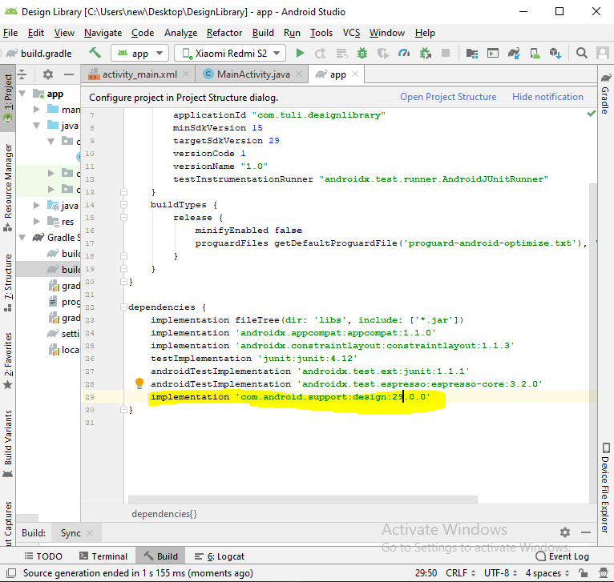

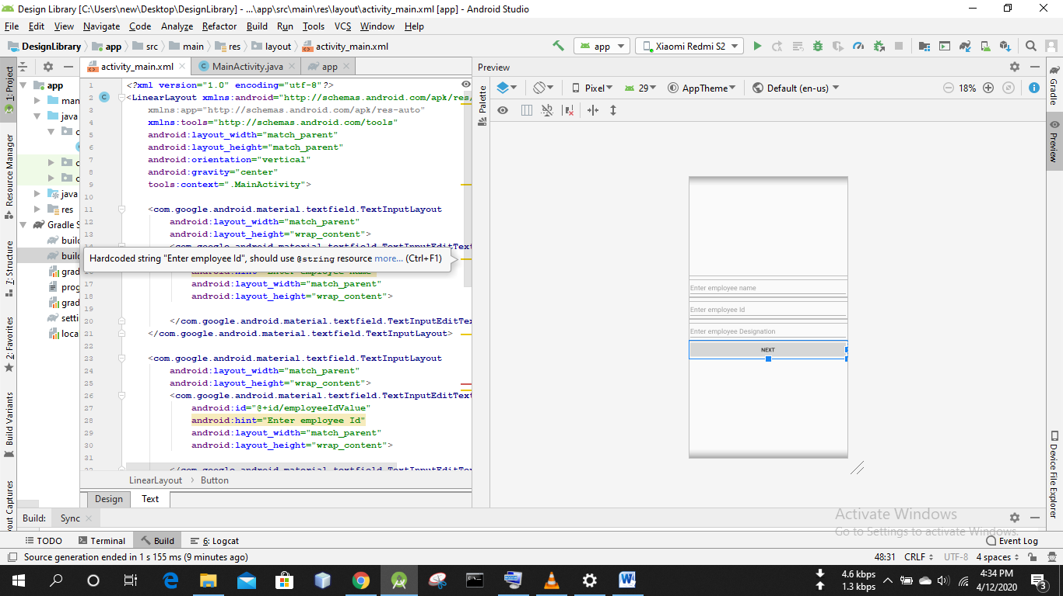

*<?***xml version="1.0" encoding="utf-8"***?>*<**LinearLayout xmlns:android="http://schemas.android.com/apk/res/android"  
 xmlns:app="http://schemas.android.com/apk/res-auto"  
 xmlns:tools="http://schemas.android.com/tools"  
 android:layout_width="match_parent"  
 android:layout_height="match_parent"  
 android:orientation="vertical"  
 android:gravity="center"  
 tools:context=".MainActivity"**>  
  
 <**com.google.android.material.textfield.TextInputLayout  
 android:layout_width="match_parent"  
 android:layout_height="wrap_content"**>  
  
 <**com.google.android.material.textfield.TextInputEditText  
 android:id="@+id/employeeNameValue"  
 android:hint="Enter employee name"  
 android:layout_width="match_parent"  
 android:layout_height="wrap_content"**>  
  
 </**com.google.android.material.textfield.TextInputEditText**>  
 </**com.google.android.material.textfield.TextInputLayout**>  
  
 <**com.google.android.material.textfield.TextInputLayout  
 android:layout_width="match_parent"  
 android:layout_height="wrap_content"**>  
  
 <**com.google.android.material.textfield.TextInputEditText  
 android:id="@+id/employeeIdValue"  
 android:hint="Enter employee Id"  
 android:layout_width="match_parent"  
 android:layout_height="wrap_content"**>  
  
 </**com.google.android.material.textfield.TextInputEditText**>  
 </**com.google.android.material.textfield.TextInputLayout**>  
  
 <**com.google.android.material.textfield.TextInputLayout  
 android:layout_width="match_parent"  
 android:layout_height="wrap_content"**>  
  
 <**com.google.android.material.textfield.TextInputEditText  
 android:id="@+id/employeeDesignationValue"  
 android:hint="Enter employee Designation"  
 android:layout_width="match_parent"  
 android:layout_height="wrap_content"**>  
  
 </**com.google.android.material.textfield.TextInputEditText**>  
 </**com.google.android.material.textfield.TextInputLayout**>  
  
 <**Button  
 android:onClick="gotoAddressActivity"  
 android:text="next"  
 android:layout_width="match_parent"  
 android:layout_height="wrap_content"**>  
  
 </**Button**>  
  
</**LinearLayout**>

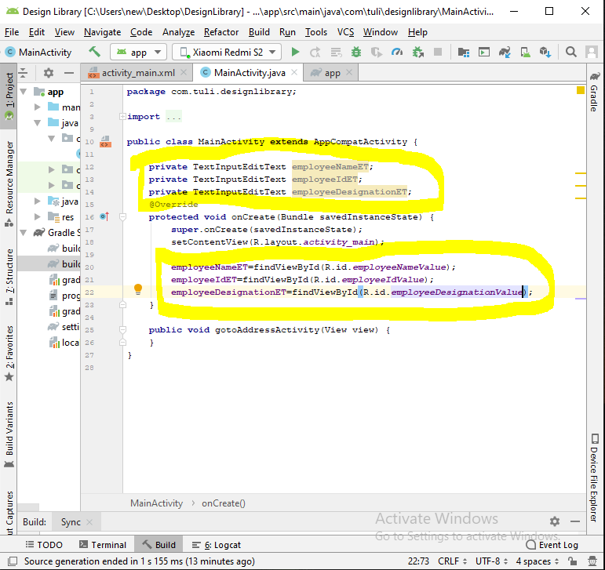

**package** com.tuli.designlibrary;  
  
**import** androidx.appcompat.app.AppCompatActivity;  
  
**import** android.os.Bundle;  
**import** android.view.View;  
  
**import** com.google.android.material.textfield.TextInputEditText;  
  
**public class** MainActivity **extends** AppCompatActivity {  
  
 **private** TextInputEditText **employeeNameET**;  
 **private** TextInputEditText **employeeIdET**;  
 **private** TextInputEditText **employeeDesignationET**;  
 @Override  
 **protected void** onCreate(Bundle savedInstanceState) {  
 **super**.onCreate(savedInstanceState);  
 setContentView(R.layout.***activity_main***);  
  
 **employeeNameET**=findViewById(R.id.***employeeNameValue***);  
 **employeeIdET**=findViewById(R.id.***employeeIdValue***);  
 **employeeDesignationET**=findViewById(R.id.***employeeDesignationValue***);  
 }  
  
 **public void** gotoAddressActivity(View view) {  
 }  
}

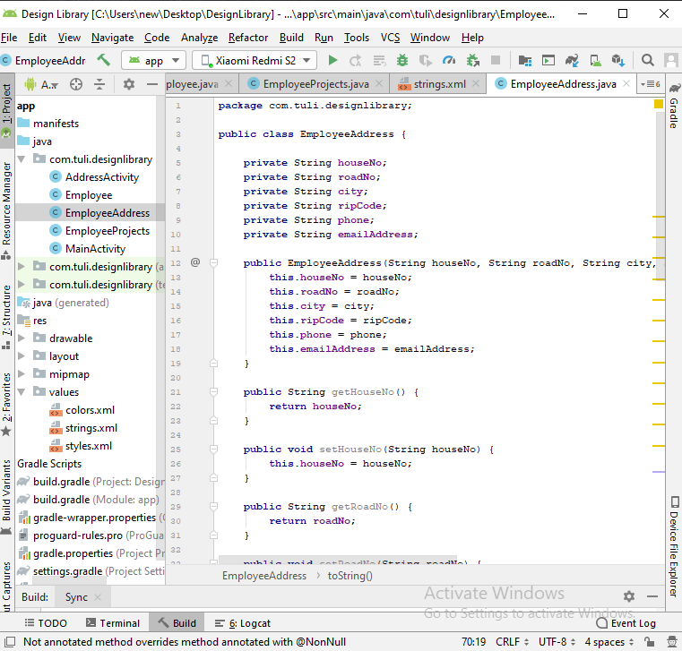

**package** com.tuli.designlibrary;  
  
**public class** EmployeeAddress {  
  
 **private** String **houseNo**;  
 **private** String **roadNo**;  
 **private** String **city**;  
 **private** String **ripCode**;  
 **private** String **phone**;  
 **private** String **emailAddress**;  
  
 **public** EmployeeAddress(String houseNo, String roadNo, String city, String ripCode, String phone, String emailAddress) {  
 **this**.**houseNo** = houseNo;  
 **this**.**roadNo** = roadNo;  
 **this**.**city** = city;  
 **this**.**ripCode** = ripCode;  
 **this**.**phone** = phone;  
 **this**.**emailAddress** = emailAddress;  
 }  
  
 **public** String getHouseNo() {  
 **return houseNo**;  
 }  
  
 **public void** setHouseNo(String houseNo) {  
 **this**.**houseNo** = houseNo;  
 }  
  
 **public** String getRoadNo() {  
 **return roadNo**;  
 }  
  
 **public void** setRoadNo(String roadNo) {  
 **this**.**roadNo** = roadNo;  
 }  
  
 **public** String getCity() {  
 **return city**;  
 }  
  
 **public void** setCity(String city) {  
 **this**.**city** = city;  
 }  
  
 **public** String getRipCode() {  
 **return ripCode**;  
 }  
  
 **public void** setRipCode(String ripCode) {  
 **this**.**ripCode** = ripCode;  
 }  
  
 **public** String getPhone() {  
 **return phone**;  
 }  
  
 **public void** setPhone(String phone) {  
 **this**.**phone** = phone;  
 }  
  
 **public** String getEmailAddress() {  
 **return emailAddress**;  
 }  
  
 **public void** setEmailAddress(String emailAddress) {  
 **this**.**emailAddress** = emailAddress;  
 }  
  
 @Override  
 **public** String toString() {  
 **return "EmployeeAddress{"** +  
 **"houseNo='"** + **houseNo** + **'\''** +  
 **", roadNo='"** + **roadNo** + **'\''** +  
 **", city='"** + **city** + **'\''** +  
 **", ripCode='"** + **ripCode** + **'\''** +  
 **", phone='"** + **phone** + **'\''** +  
 **", emailAddress='"** + **emailAddress** + **'\''** +  
 **'}'**;  
 }  
}

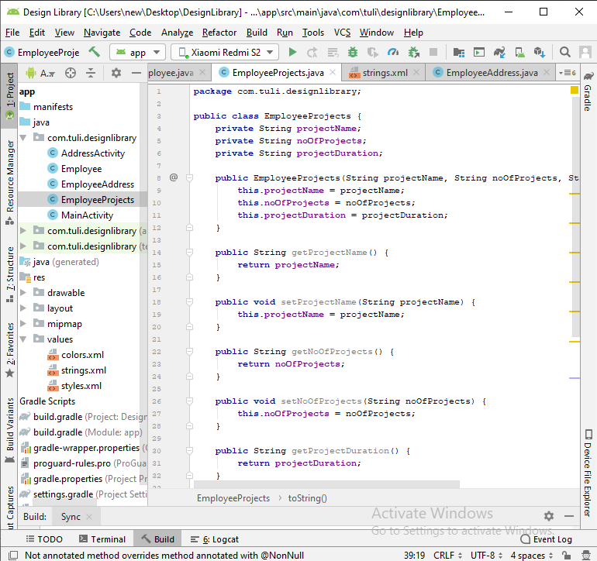

**package** com.tuli.designlibrary;  
  
**public class** EmployeeProjects {  
 **private** String **projectName**;  
 **private** String **noOfProjects**;  
 **private** String **projectDuration**;  
  
 **public** EmployeeProjects(String projectName, String noOfProjects, String projectDuration) {  
 **this**.**projectName** = projectName;  
 **this**.**noOfProjects** = noOfProjects;  
 **this**.**projectDuration** = projectDuration;  
 }  
  
 **public** String getProjectName() {  
 **return projectName**;  
 }  
  
 **public void** setProjectName(String projectName) {  
 **this**.**projectName** = projectName;  
 }  
  
 **public** String getNoOfProjects() {  
 **return noOfProjects**;  
 }  
  
 **public void** setNoOfProjects(String noOfProjects) {  
 **this**.**noOfProjects** = noOfProjects;  
 }  
  
 **public** String getProjectDuration() {  
 **return projectDuration**;  
 }  
  
 **public void** setProjectDuration(String projectDuration) {  
 **this**.**projectDuration** = projectDuration;  
 }  
  
 @Override  
 **public** String toString() {  
 **return "EmployeeProjects{"** +  
 **"projectName='"** + **projectName** + **'\''** +  
 **", noOfProjects='"** + **noOfProjects** + **'\''** +  
 **", projectDuration='"** + **projectDuration** + **'\''** +  
 **'}'**;  
 }  
}

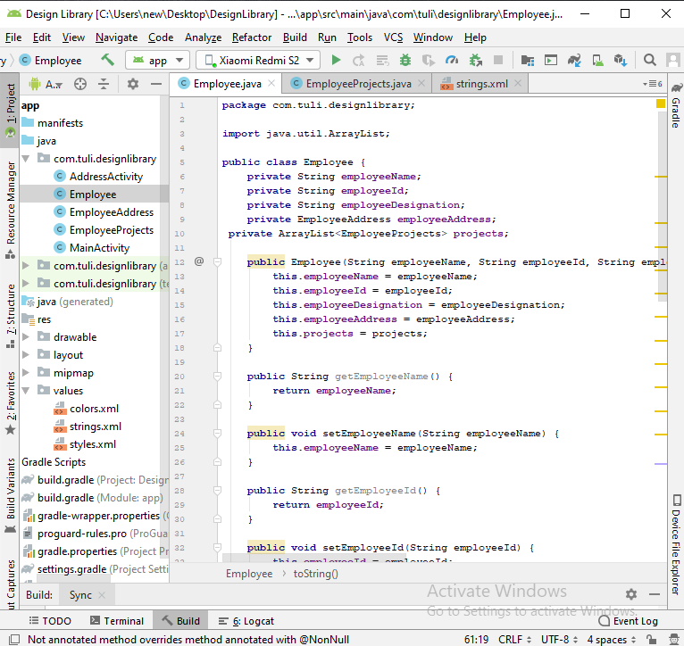

**package** com.tuli.designlibrary;  
  
**import** java.util.ArrayList;  
  
**public class** Employee {  
 **private** String **employeeName**;  
 **private** String **employeeId**;  
 **private** String **employeeDesignation**;  
 **private** EmployeeAddress **employeeAddress**;  
 **private** ArrayList<EmployeeProjects> **projects**;  
  
 **public** Employee(String employeeName, String employeeId, String employeeDesignation, EmployeeAddress employeeAddress, ArrayList<EmployeeProjects> projects) {  
 **this**.**employeeName** = employeeName;  
 **this**.**employeeId** = employeeId;  
 **this**.**employeeDesignation** = employeeDesignation;  
 **this**.**employeeAddress** = employeeAddress;  
 **this**.**projects** = projects;  
 }  
  
 **public** String getEmployeeName() {  
 **return employeeName**;  
 }  
  
 **public void** setEmployeeName(String employeeName) {  
 **this**.**employeeName** = employeeName;  
 }  
  
 **public** String getEmployeeId() {  
 **return employeeId**;  
 }  
  
 **public void** setEmployeeId(String employeeId) {  
 **this**.**employeeId** = employeeId;  
 }  
  
 **public** String getEmployeeDesignation() {  
 **return employeeDesignation**;  
 }  
  
 **public void** setEmployeeDesignation(String employeeDesignation) {  
 **this**.**employeeDesignation** = employeeDesignation;  
 }  
  
 **public** EmployeeAddress getEmployeeAddress() {  
 **return employeeAddress**;  
 }  
  
 **public void** setEmployeeAddress(EmployeeAddress employeeAddress) {  
 **this**.**employeeAddress** = employeeAddress;  
 }  
  
 **public** ArrayList<EmployeeProjects> getProjects() {  
 **return projects**;  
 }  
  
 **public void** setProjects(ArrayList<EmployeeProjects> projects) {  
 **this**.**projects** = projects;  
 }  
  
 @Override  
 **public** String toString() {  
 **return "Employee{"** +  
 **"employeeName='"** + **employeeName** + **'\''** +  
 **", employeeId='"** + **employeeId** + **'\''** +  
 **", employeeDesignation='"** + **employeeDesignation** + **'\''** +  
 **", employeeAddress="** + **employeeAddress** +  
 **", projects="** + **projects** +  
 **'}'**;  
 }  
}

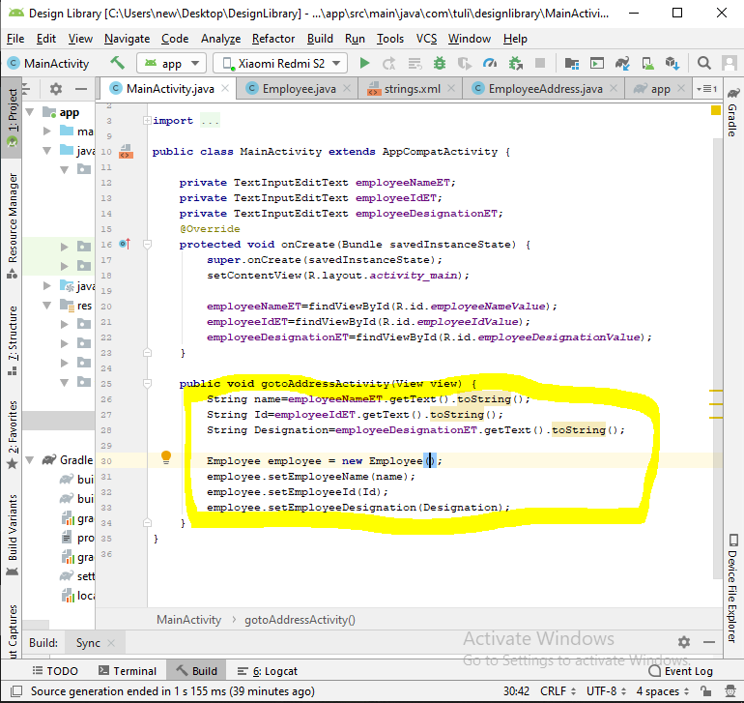

Create New Activity- Address activity

